Bug ID | TestCase ID-4
Originator | Gorjan Kalauzovic | Email: | Phone:
Submit Date | 22/08/2018
Summary | Number of filtered files in the filters section when clicked does not correspond to the number of filtered search results.
Severity | Low
Product | Allexis
Component | Artist Filter
Version | 1.0
Platform | PC
OS | Windows
Browser | Chrome 68
URL | https://store.demo.allexis.digital/

Steps to repoduce
1. Write the url - https://store.demo.allexis.digital in the browser's URL bar and press enter.
2. Once allexis is launched, write the search term - "David Guetta" in the search bar.
3. Press enter.
4. Verify that there is results for the searched term.
5. Activate Search filter (Artists-David Bowie)
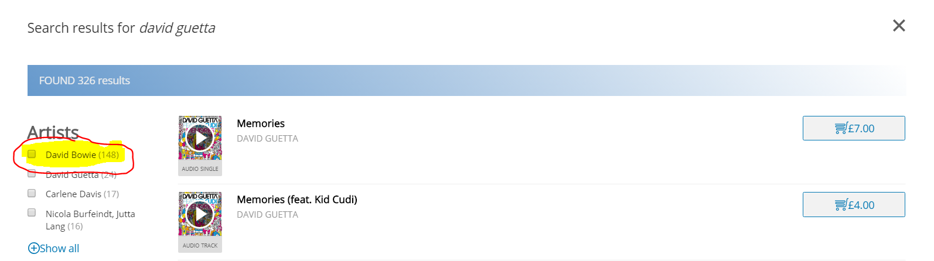

6. After selecting the filter the Search results do not match with the filter results
